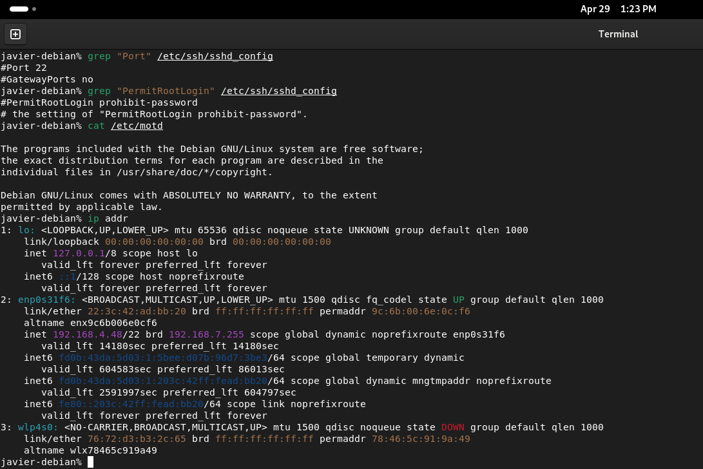
Before changes were made:

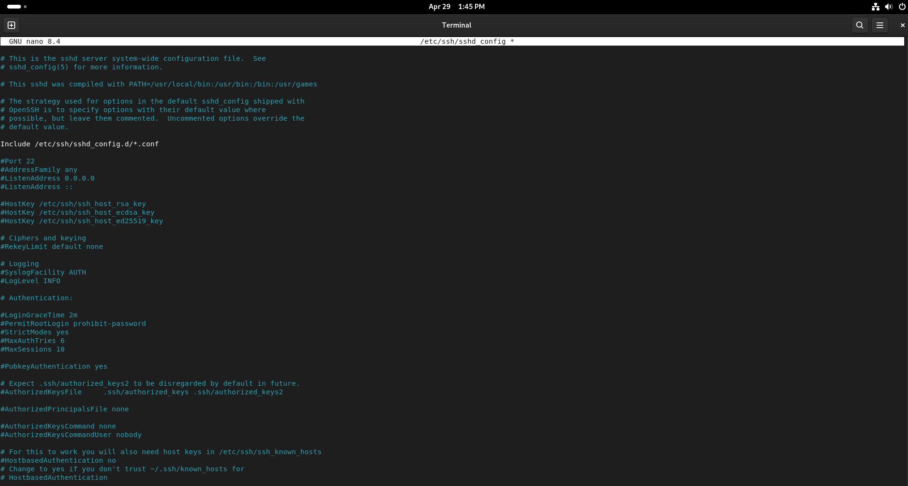

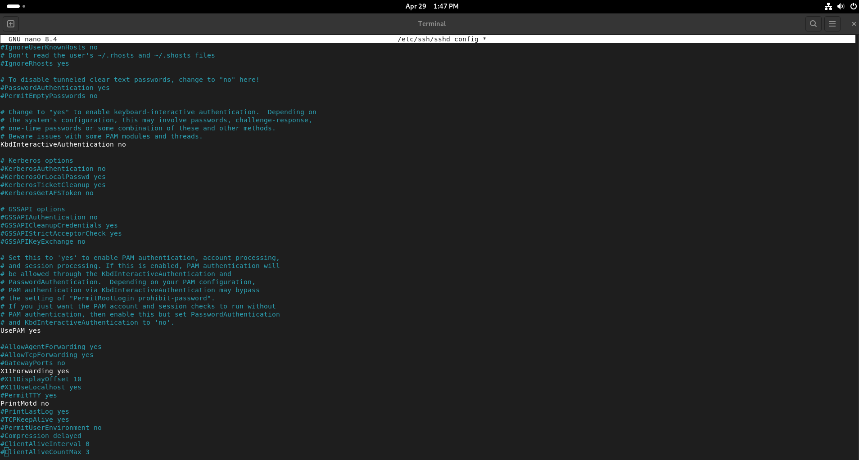
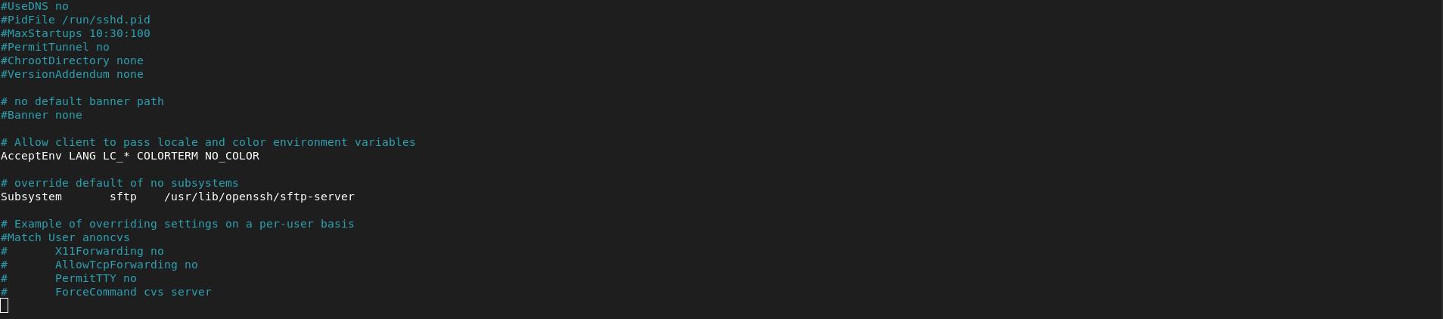
Changes that were made

Updated Banner:
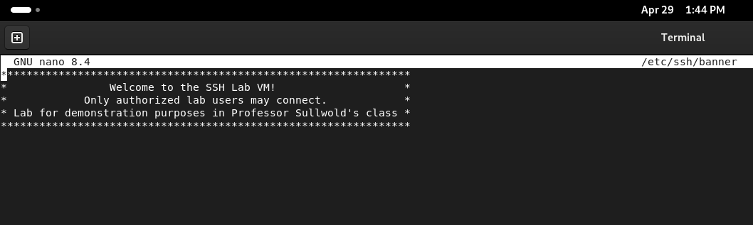

Updated MOTD:
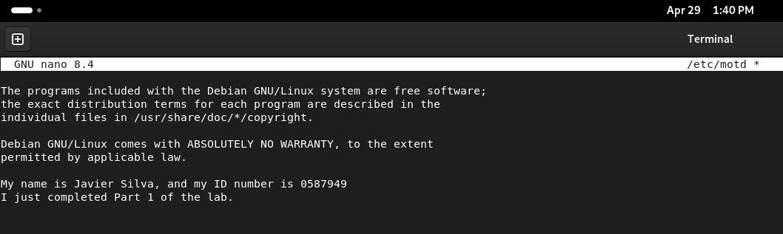

Updated SSH Config:
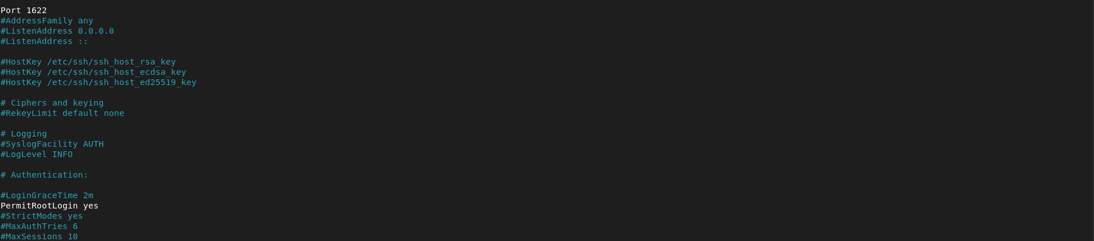

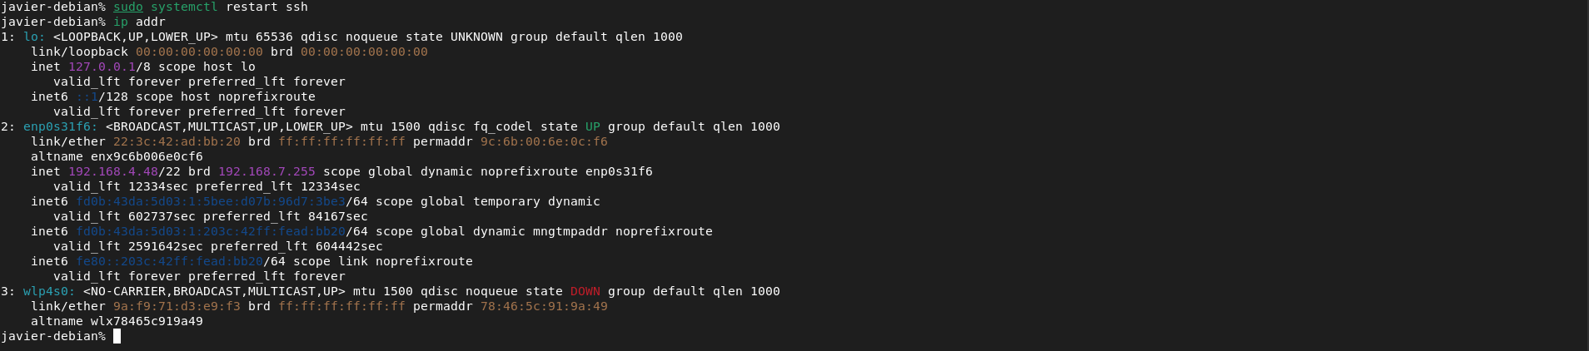

PART 1

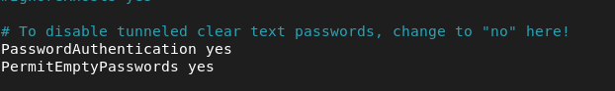

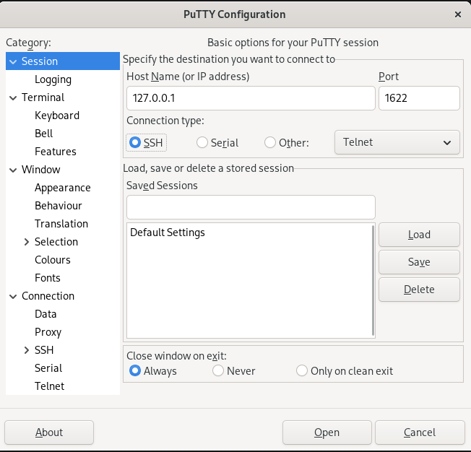

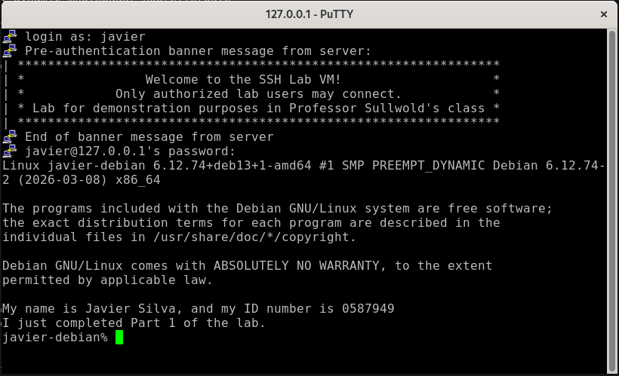

Part 2

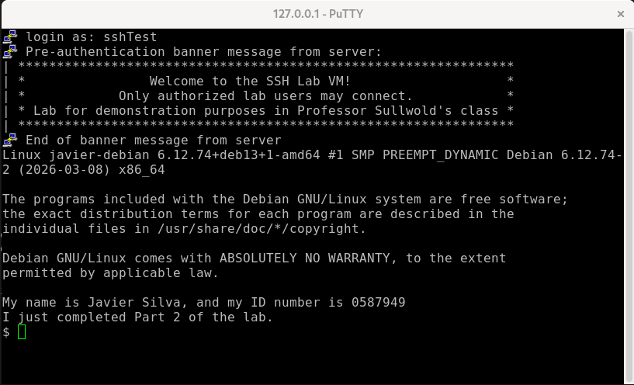

Part 3
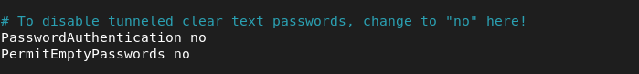

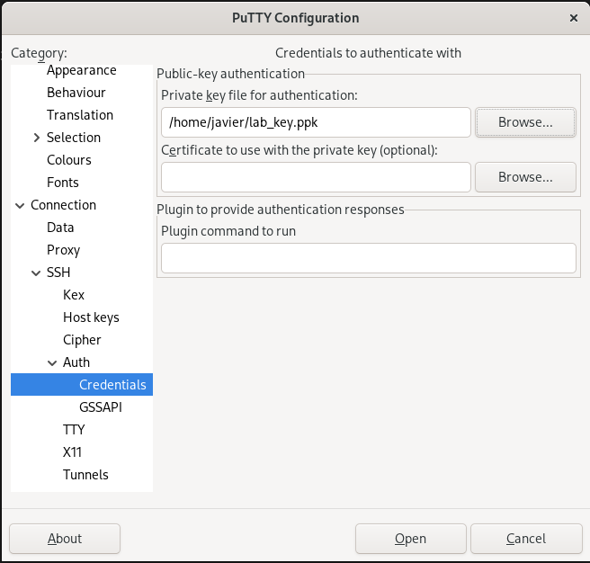

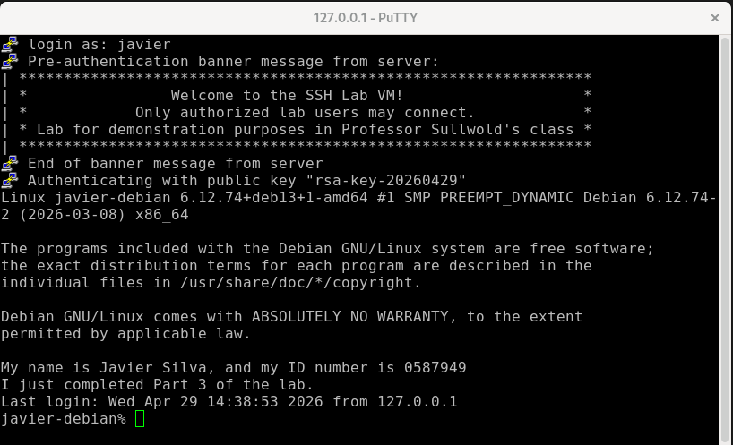

COMMAND EXPLANATIONS

Part 1
sudo nano /etc/ssh/banner
- Explanation: Creates the custom text file to serve as the pre-login warning banner. Necessary to fulfill the lab requirement for a pre-login warning.
sudo nano /etc/motd
- Explanation: Modifies the "Message of the Day" file. Necessary to display the required student name, ID, and Part 1 completion status after a successful login.
sudo nano /etc/ssh/sshd_config
- Explanation: Opens the primary SSH daemon configuration file. Necessary to change the listening port to 1622, enable root login, enforce password authentication, and point the service to the custom banner file.
sudo systemctl restart ssh
- Explanation: Restarts the SSH service. Necessary so the configuration changes made in sshd_config take effect.
ip addr
- Explanation: Displays network interface information. Necessary to identify the IP address of the Linux VM to connect to it via PuTTY from the host machine.

Part 2

sudo useradd -m sshTest
- Explanation: Creates a new user account named sshTest and generates a home directory (-m) for them. Necessary to fulfill the requirement of creating the specific lab user.
sudo passwd -d sshTest
- Explanation: Deletes the password for the sshTest account (-d flag), leaving it blank. Necessary to allow authentication without a password.
sudo nano /etc/ssh/sshd_config (Part 2 update)
- Explanation: Modified the configuration to set PermitEmptyPasswords yes. This is necessary because SSH blocks accounts with blank passwords by default; this explicitly overrides that security measure.

Part 3
mkdir -p ~/.ssh
- Explanation: Creates the .ssh directory in the user's home folder if it doesn't already exist. Necessary to hold the authorized keys file.
nano ~/.ssh/authorized_keys
- Explanation: Creates/edits the file that stores approved public SSH keys. Necessary to tell the SSH server to trust the specific key generated by the client machine.
chmod 600 ~/.ssh/authorized_keys
- Explanation: Restricts read and write permissions to the owner only. Necessary because the SSH service will reject key files that are accessible by other users for security reasons.
sudo nano /etc/ssh/sshd_config (Part 3 update)
- Explanation: Modified the configuration to set PasswordAuthentication no and PermitEmptyPasswords no. Necessary to enforce key-based authentication exclusively and meet the requirement of demonstrating that passwords no longer work.

